**VISVESVARAYA TECHNOLOGICAL UNIVERSITY**

**“Jnana Sangama”, Belgaum -590014, Karnataka.**



**PROJECT WORK-1 REPORT**

**on**

**MORINGA OLEIFERA**

***Submitted by***

**Neelesh Gangopadhyay(1BM18CS058)**

**Raghav Mittal(1BM18CS075)**

**Mokshith D.V (1BM18CS055)**

**Yashaswi R(1BM18ME190)**

***Under the Guidance of***

**Mrs. SHEETAL V A**

**Assistant Professor, BMSCE**

***in partial fulfillment for the award of the degree of***

**BACHELOR OF ENGINEERING**

***in***

**COMPUTER SCIENCE AND ENGINEERING**



**B.M.S. COLLEGE OF ENGINEERING**

**(Autonomous Institution under VTU)**

**BENGALURU-560019**

**DEC 2019**

**B. M. S. College of Engineering,**

**Bull Temple Road, Bangalore 560019**

(Affiliated To Visvesvaraya Technological University, Belgaum)

**Department of Computer Science and Engineering**

  **CERTIFICATE**

This is to certify that the project work entitled “**MORINGA OLEIFERA**” carried out by **Neelesh Gangopadhyay (1BM11CS058), Raghav Mittal (1BM18CS075), Mokshith D.V (1BM18CS055) and Yashaswi R (1BM18ME190)** who are bonafide students of **B. M. S. College of Engineering.** It is in partial fulfillment for the award of **Bachelor of Engineering in Computer Science and Engineering** of the Visveswaraiah Technological University, Belgaum during the year 2019. The project report has been approved as it satisfies the academic requirements in respect of **Project Work-1 (19CS3PWPW1)**work prescribed for the said degree.

Signature of the Guide                 Signature of the HOD

Mr. Sheetal V A Dr. V. Umadevi

Assistant Professor Prof & Head of Dept of CSE

BMSCE, Bengaluru BMSCE, Bengaluru

External Viva

Name of the Examiner                                                                                       Signature with date

1._____________________________ ________________________

2. _____________________________ _________________________

**B.M.S. College of EngineerinG**

**DEPARTMENT OF COMPUTER SCIENCE AND ENGINEERING**



***DECALARATION***

We, **Neelesh Gangopadhyay (1BM18CS058)**,  **Raghav Mittal (1BM18CS075)**, **Mokshith D.V** (1BM18CS055), **Yashaswi** (1BM18ME190), students of 3rd Semester, B.E, Department of Computer Science and Engineering, BMS College of Engineering, Bangalore, hereby declare that, this Project Work-1 entitled "Project Title" has been carried out by us under the guidance of **Prof. Sheetal V A**, Assistant Professor, Department of CSE, BMS College of Engineering, Bangalore during the academic semester Aug-Dec 2019.

We also declare that to the best of our knowledge and belief, the development reported here is not from part of any other report by any other students.

Name Signature

Neelesh Gangopadhyay (1BM18CS058)

Raghav Mittal(1BM18CS075)

Mokshith D.V(1BM18CS055)

Yashaswi R(1BM18ME190)

**TABLE OF CONTENTS**

|  |  |  |
| --- | --- | --- |
| **CHAPTER NO.** | **TITLE** | **PAGE NO.** |
| 1 | **Introduction** | 1 |
| 1.1 | Overview | 1 |
| 1.2 | Motivation | 1 |
| 2 | **Software Requirement Specification** | 2 |
| 2.1 | Hardware Requirements | 2 |
| 2.2 | Software Requirements | 2 |
| 3 | **User Interface Design** | 3 |
| 3.1 | Login screen | 3 |
| 3.2 | Home Page | 4 |
| 3.3 | Configuration Page | 5 |

**Chapter 1**

**INTRODUCTION**

**Chapter 1**

**INTRODUCTION**

* **Overview**

E-Commerce (Electronic Commerce) is process of doing business through online portal. The primary goal of an e-commerce site is to sell goods and provide services to the customers online. Online shopping is now become widely used where the customer can order the desired items through the online portal and get the items delivered at their door step. a form of electronic shopping store where the buyer is directly online to the seller’s computer.

In traditional system, the people used plant nursery that is carried out physically with effort of a person to go and get products. The basic concept of the application is to allow the customer to shop virtually using the Internet and allow customers to buy the items and articles of their desire from the store.

The proposed system helps in building a website to buy plants online. Customer can login and get various information about plants and can purchase the suitable plants. In order to solve this, B2C E-Commerce website has been developed.

**1.2 Motivation**

Our major advantages can be summarized as follows:

* Faster buying/selling procedure, as well as easy to find plants.
* More reach to plant enthusiasts and customers, there is no theoretical geographic limitations.
* Low operational costs and better quality of services.
* No need of physical plant store set-ups.
* Customers can easily select plants from different variety offered without wasting time and energy.
* Use of html, css and javascript to provide seamless experience and feature rich webpages.

**Chapter 2**

SOFTWARE REQUIREMENTS

**2.1 Hardware Requirements:**

* A PC with the following or greater specifications:
  + Intel Core i7 (6th gen or higher)
  + 8 GB RAM
  + 500 GB Hard Drive
* A stable internet connection (2Mbps or higher).

**2.2 Software Requirements:**

* Operating system : Windows 10
* Technologies : HTML, CSS, Javascript
* IDE : Notepad, Notepad++
* Database : MySQL

**Chapter 3**

**USER INTERFACE DESIGN**

* **Registration Screen**

DESCRIPTION:

1.This is the first page and also the registration page.

2.This page accepts the personal details provided by the user such as name,username,password and mobile no .

3.This page register the new users to E-commerce site.

4.Sign in link is provided for already registered users.

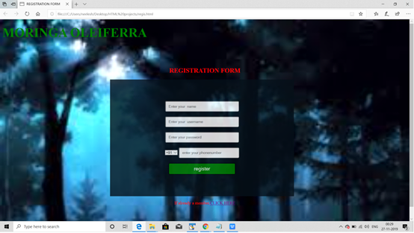

**Fig.1 Registration Screen**

**LOGIN PAge**

DESCRIPTION:

1.This page provides already registered users to login by filling up their username and password.

2.Upon successfully signing in,the users are directed buy page.

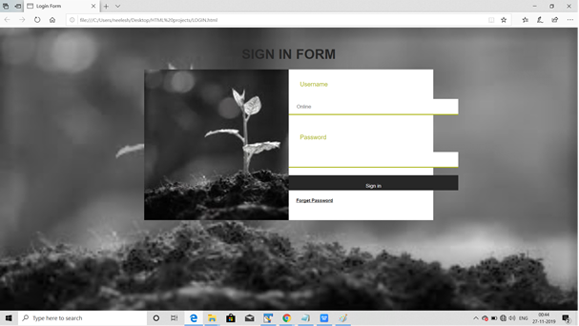

**Fig.1 Login Page**

**Buy page**

DESCRIPTION**:**

2.By clicking on BUY ,we are directed to lister page containing list of plants.

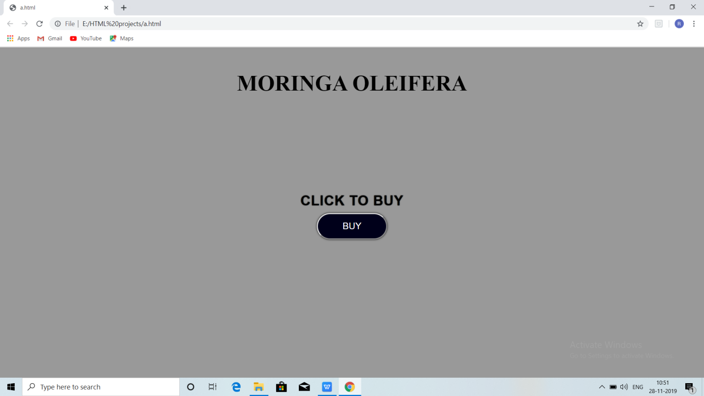 Fig.3 Buy page

**PLANTS LISTER PAGE**

DESCRIPTION:

1.This is a basic user interface page.

1.This page provides the image, name and price of the plants.

2.By clicking on the particular image, we move directly to the description of that particular plant.

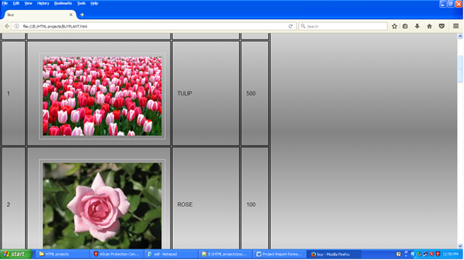 Fig.4 Lister Page

DESCRIPTION PAGE

DESCRIPTION:

1.This page provides the scientific name of a particular chosen plant.

2.Its description, along with its image.

3.There is an option to enlarge the plant if necessary.

4.There is an option to enter the number of saplings a customer wants to buy.

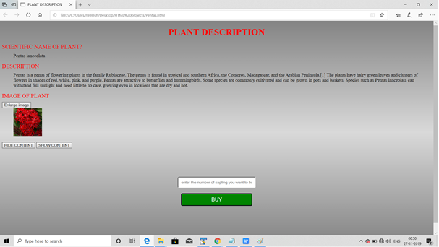 Fig.5 Description page

**Invoice**

DESCRIPTION:

1.This page provides the info that order had been submitted.

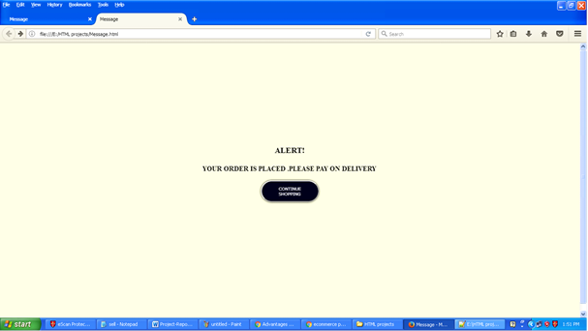 Fig.6 Invoice page